WEEK 2
Exploratory Data Analysis and Visualization
Titanic Passenger Dataset

Python Data Science Internship
Pandas • Matplotlib • Seaborn-compatible analytical workflow
Prepared as a reproducible EDA study using the cleaned dataset produced in Week 1.

Executive Summary
This report presents a structured exploratory data analysis (EDA) of the Titanic passenger dataset. The analysis builds directly on the cleaned dataset prepared during Week 1, allowing the EDA to focus on discovering patterns rather than repeating data-quality remediation. The dataset contains 891 passenger records and 19 analytical fields after the Week 1 cleaning and feature-engineering process.
The overall survival rate is 38.4%. The strongest descriptive differences appear across sex and passenger class: female passengers have a survival rate of 74.2%, compared with 18.9% for male passengers. First-class passengers have a survival rate of 63.0%, versus 24.2% in third class.
The report combines descriptive statistics, grouped aggregations, distribution analysis, categorical comparisons, multivariate analysis, and correlation analysis. Visualizations are annotated with titles, axis labels, and legends where applicable. Importantly, the findings are interpreted as associations in an observational historical dataset; the analysis does not claim that any single variable caused survival.

1. Objectives and EDA Questions
The Week 2 objective is to use Python-based EDA to summarize the dataset and uncover meaningful trends, patterns, and anomalies.
- Understand the distributions of the main numerical and categorical variables.
- Measure survival rates across sex, passenger class, age groups, embarkation port, and family-travel status.
- Examine whether family size and traveling alone are associated with different survival outcomes.
- Explore the relationship between fare and passenger class.
- Inspect correlations among selected numerical features.
- Transform and aggregate variables where doing so improves interpretability.
- Translate visual patterns into concise, evidence-based observations.

2. Dataset and Analytical Setup
The source for this analysis is the cleaned Titanic passenger dataset generated during Week 1. Using the Week 1 output creates continuity between the internship tasks: Week 1 addresses data quality, while Week 2 uses the cleaned data to investigate structure and relationships.
Item | Value
Rows | 891
Columns | 19
Target examined | Survived
Primary numerical variables | Age, Fare, SibSp, Parch, FamilySize
Primary categorical variables | Sex, Pclass, Embarked, Deck, AgeGroup
Engineered variables reused | FamilySize, IsAlone, Fare_log, Fare_winsorized, HasCabin
Python loading and inspection:
import pandas as pd
df = pd.read_csv("titanic_cleaned.csv")
print(df.shape)
print(df.info())
print(df.describe(include="all"))

3. Initial Statistical Exploration
The mean passenger age is 29.14 years and the median is 26. Fare is strongly right-skewed: the mean is 32.20, while the median is 14.45. FamilySize has a median of 1, indicating that most observations represent an individual traveling alone or in a small family group, with a smaller number of large-family observations.
Variable | Mean | Median | Min | Max
Age | 29.14 | 26.00 | 0.42 | 80
Fare | 32.20 | 14.45 | 0.00 | 512.329
FamilySize | 1.90 | 1 | 1 | 11
The descriptive statistics indicate that robust summaries such as the median are useful for fare because extreme values pull the mean upward.

4. Overall Survival Distribution
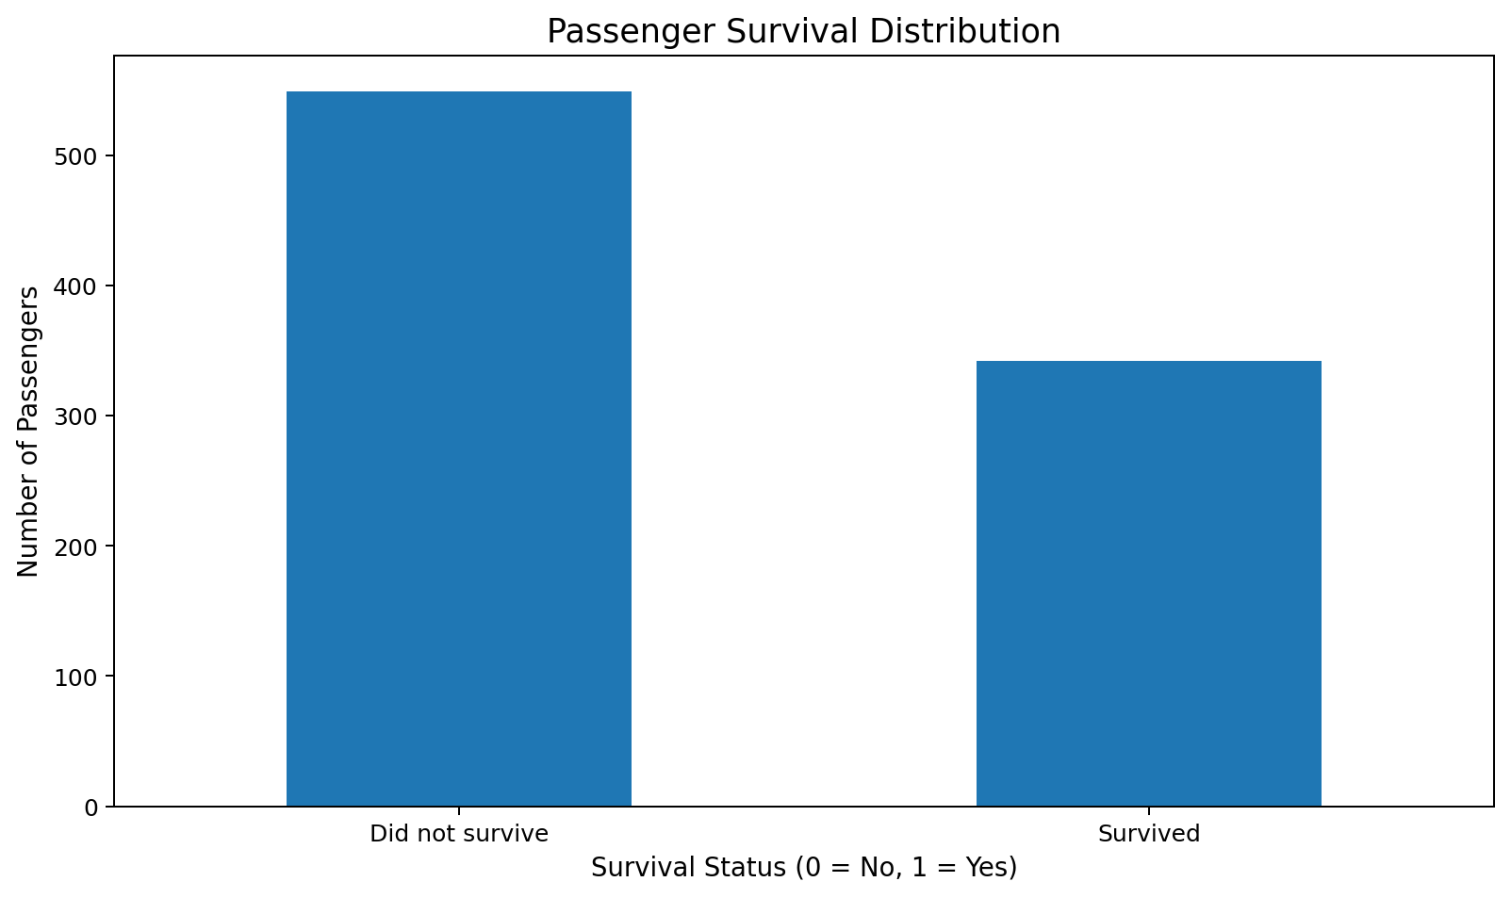
Figure 1. Distribution of survival outcomes.
Of the 891 records, 342 passengers survived and 549 did not. This corresponds to an overall survival rate of 38.4%. The outcome is therefore imbalanced, although not so extreme that the minority class disappears from analysis.
survival_counts = df["Survived"].value_counts().sort_index()
print(survival_counts)
print("Survival rate:", df["Survived"].mean())

5. Survival by Sex
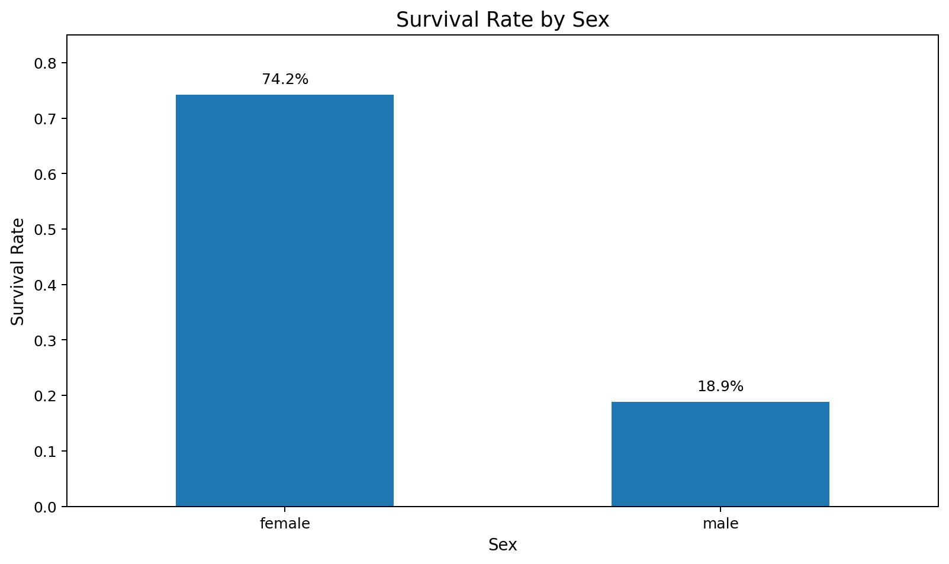
Figure 2. Survival rate by sex.
Female passengers have a survival rate of 74.2%, while male passengers have a survival rate of 18.9%. The difference is large and is one of the most prominent patterns in the dataset.
A reasonable historical interpretation is that evacuation decisions and social norms prioritized women and children. However, this EDA cannot independently establish the mechanism; it only demonstrates a strong association between sex and recorded survival.
sex_summary = df.groupby("Sex")["Survived"].agg(["count", "mean"])
print(sex_summary)

6. Survival by Passenger Class
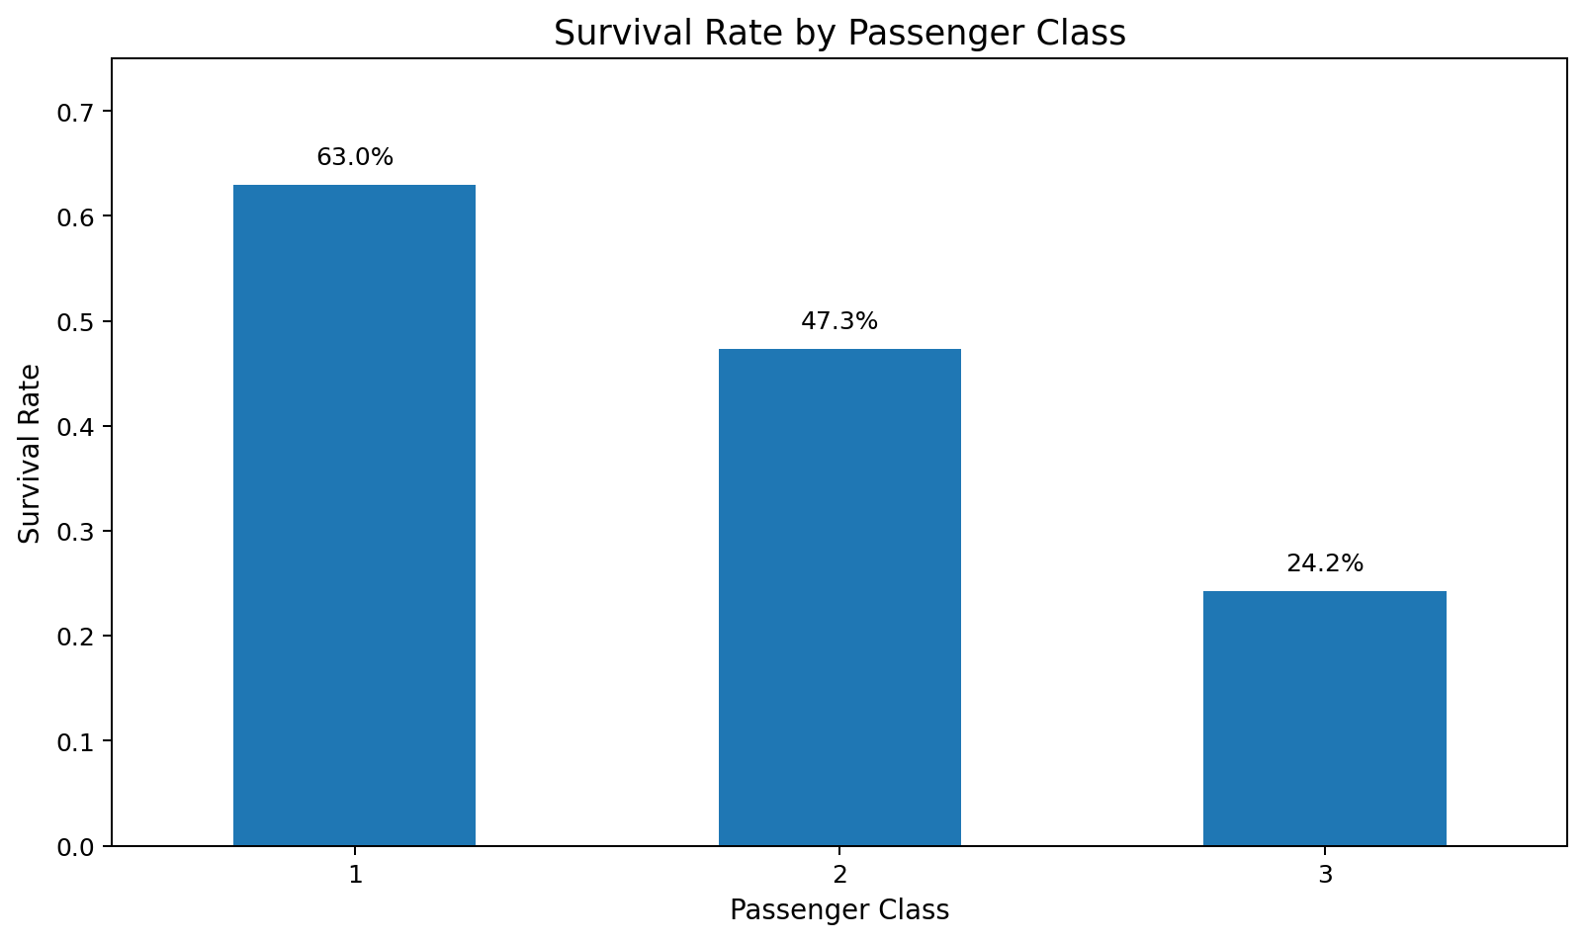
Figure 3. Survival rate by passenger class.
Survival declines systematically from first to third class: 63.0% in first class, 47.3% in second class, and 24.2% in third class.
Passenger class is likely acting as a proxy for several correlated factors, including location on the ship, access to resources, and social position. The result should therefore be interpreted as a class-associated survival pattern rather than a simple causal effect of ticket class alone.
class_summary = df.groupby("Pclass")["Survived"].agg(["count", "mean"])
print(class_summary)

7. Multivariate Analysis: Sex × Class
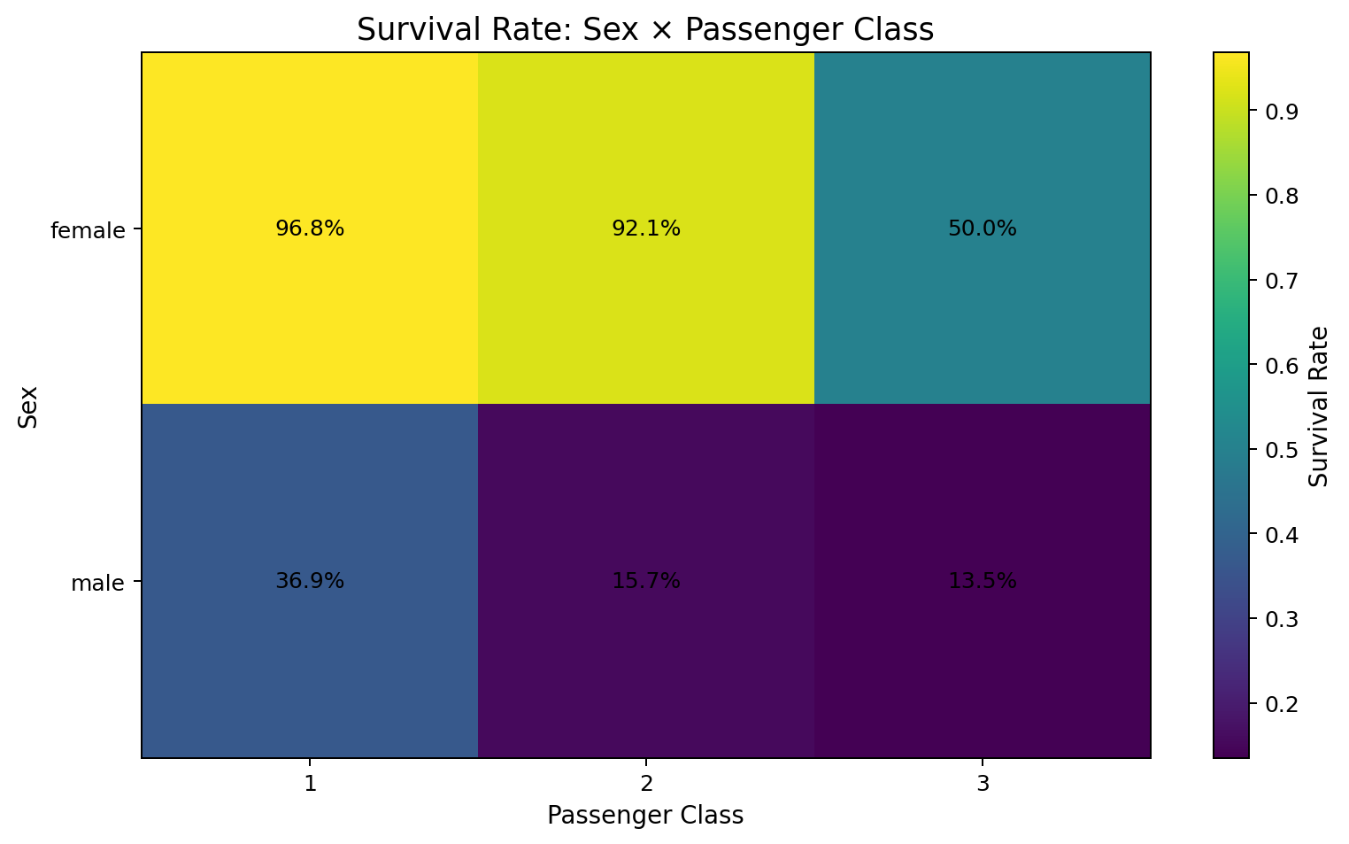
Figure 4. Combined effect pattern of sex and passenger class.
The interaction-style heatmap shows that sex and passenger class are not isolated dimensions. Female survival remains higher than male survival within each class, while higher classes generally correspond to better outcomes. This is an important EDA finding because a one-variable summary can hide meaningful subgroup differences.
The appropriate next step in a predictive project would be to include both variables rather than relying on either one alone.

8. Age Distribution and Survival
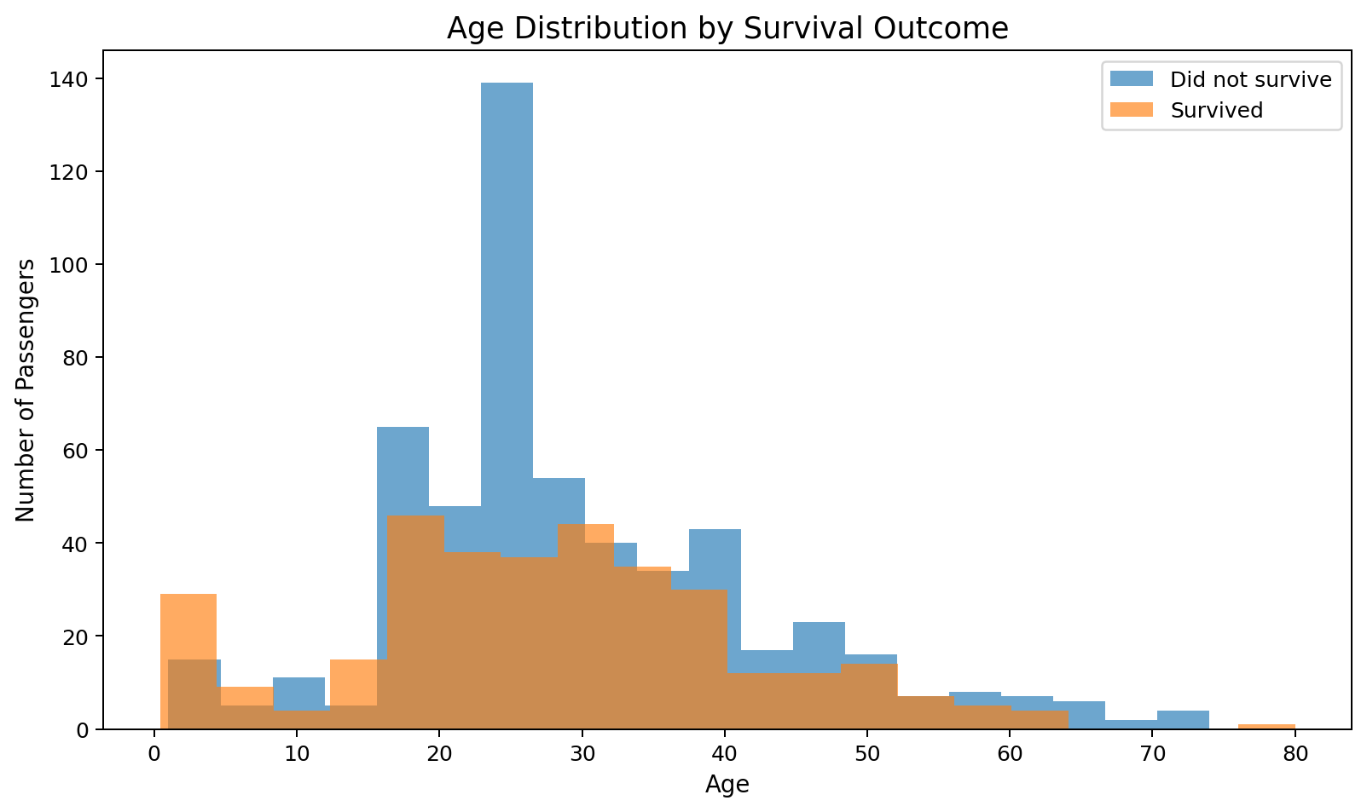
Figure 5. Age distributions separated by survival outcome.
The age distributions overlap substantially, which suggests that age alone does not cleanly separate survivors from non-survivors. Children appear relatively represented among survivors, but the plot also shows survivors and non-survivors across most adult age ranges.
The overlap is important: it prevents an exaggerated conclusion such as 'young passengers survived' and instead supports a more cautious statement that age is informative in combination with other variables.
fig, ax = plt.subplots()
ax.hist(df.loc[df["Survived"] == 0, "Age"], bins=20, alpha=.65, label="Did not survive")
ax.hist(df.loc[df["Survived"] == 1, "Age"], bins=20, alpha=.65, label="Survived")
ax.set_title("Age Distribution by Survival Outcome")
ax.set_xlabel("Age")
ax.set_ylabel("Number of Passengers")
ax.legend()
plt.show()

9. Age-Group Analysis
Age Group | Passengers | Survival Rate
Child | 73 | 57.5%
Teen | 103 | 47.6%
Adult | 469 | 33.0%
Middle-Age | 224 | 40.6%
Senior | 22 | 22.7%
The age-group aggregation provides a compact comparison across life stages. In this dataset, children have the highest observed rate among the defined groups, while senior passengers have the lowest. Small subgroup sizes should be considered when interpreting the extremes, especially for seniors.

10. Fare Distribution and Class
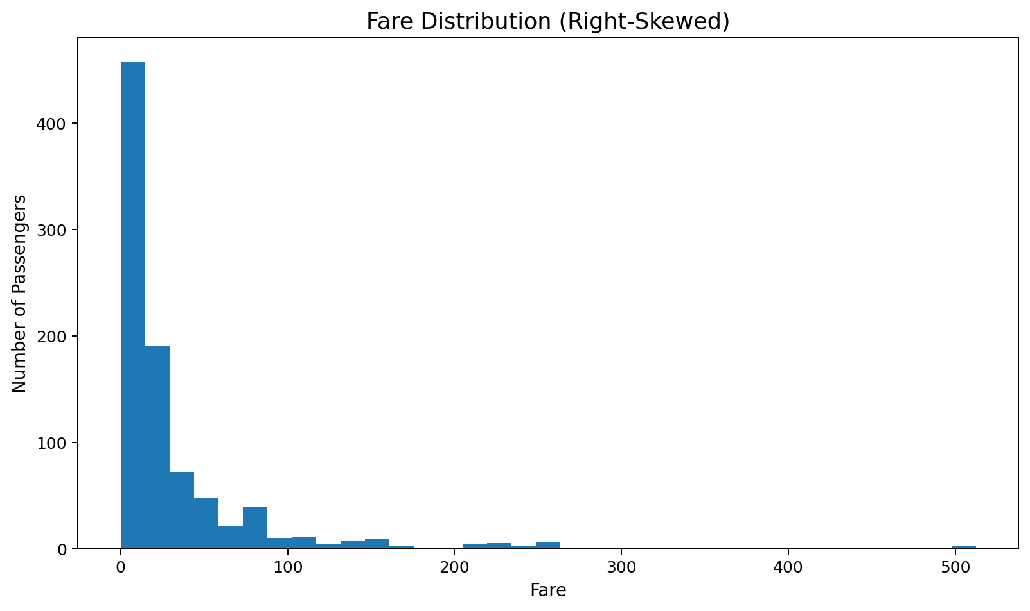
Figure 6. Fare distribution showing strong right skew.
Fare ranges from 0.00 to 512.329. The median is 14.45, much lower than the mean of 32.20. This difference demonstrates right skew caused by a relatively small number of expensive fares.
Passenger Class | Median Fare | Mean Fare
1 | 60.29 | 84.15
2 | 14.25 | 20.66
3 | 8.05 | 13.68
First-class passengers have much higher fares on average than lower classes. The fare distribution therefore contains both economic information and a class-related signal. For later modeling, transformations such as log-fare can reduce skew, but the original fare should remain available for interpretation.

11. Family Size and Survival
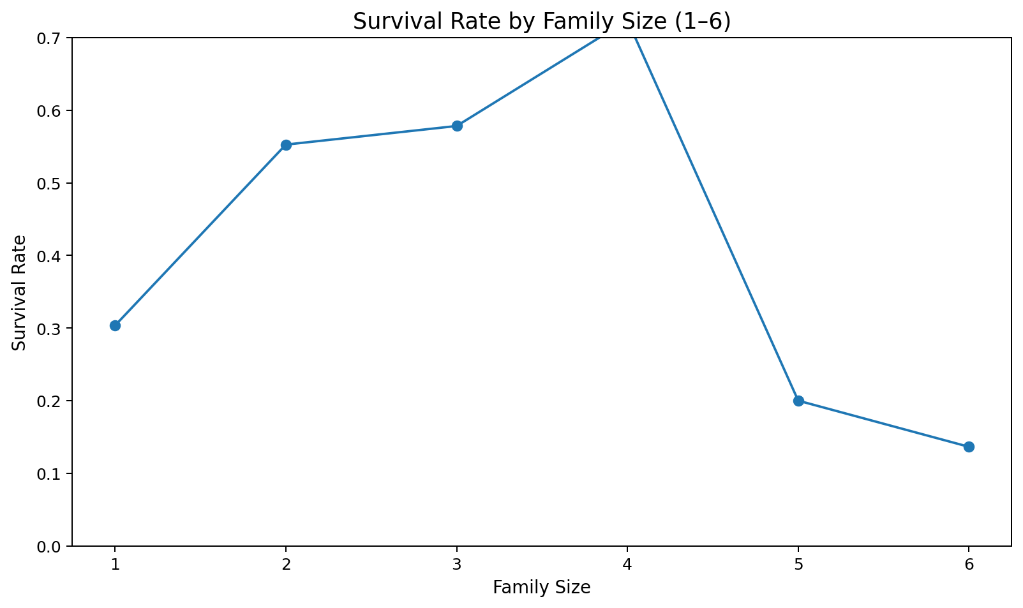
Figure 7. Survival rate by family size, restricted to sizes 1–6 for readability.
The family-size curve shows that survival is not monotonic across all family sizes. Small groups can have different outcomes from people traveling alone, while very large families become relatively uncommon. Restricting the visualization to sizes 1–6 avoids allowing a handful of rare large-family observations to dominate the visual scale.

12. Traveling Alone vs With Family
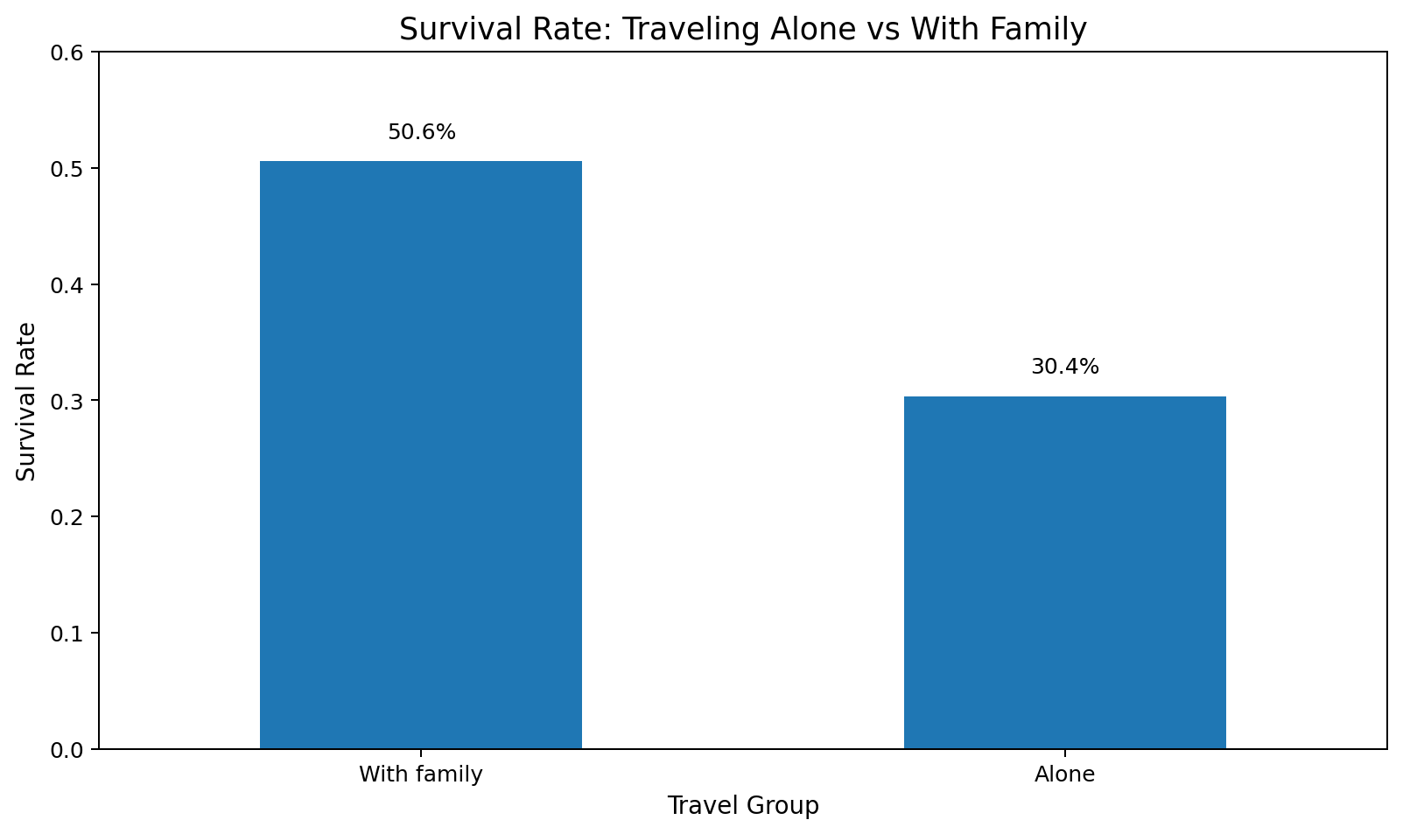
Figure 8. Survival rate by travel-alone indicator.
Passengers traveling with family have an observed survival rate of 50.6%, compared with 30.4% for passengers traveling alone.
This pattern suggests that social context may matter. However, IsAlone is also correlated with age, sex, class, and ticket/family structure, so the association should not be interpreted as an independent causal effect.

13. Port of Embarkation
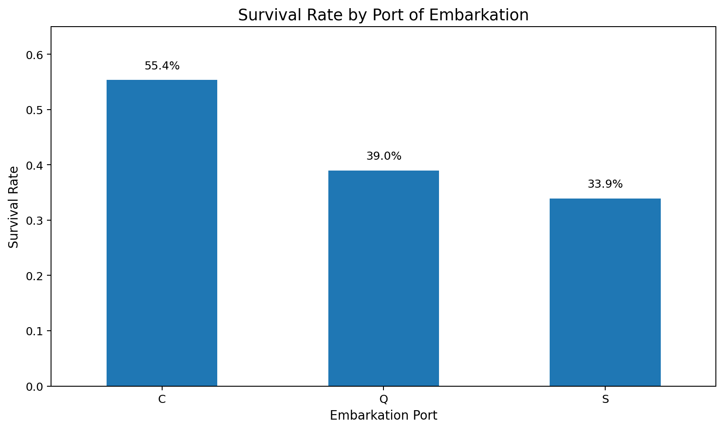
Figure 9. Survival rate by embarkation port.
The observed survival rates are 55.4% for Cherbourg (C), 39.0% for Queenstown (Q), and 33.9% for Southampton (S).
Port differences should be interpreted carefully because embarkation location is entangled with the composition of passengers using each port, including class and demographic mix. The largest group is Southampton, so its rate is also estimated from substantially more observations than Queenstown.

14. Correlation Analysis
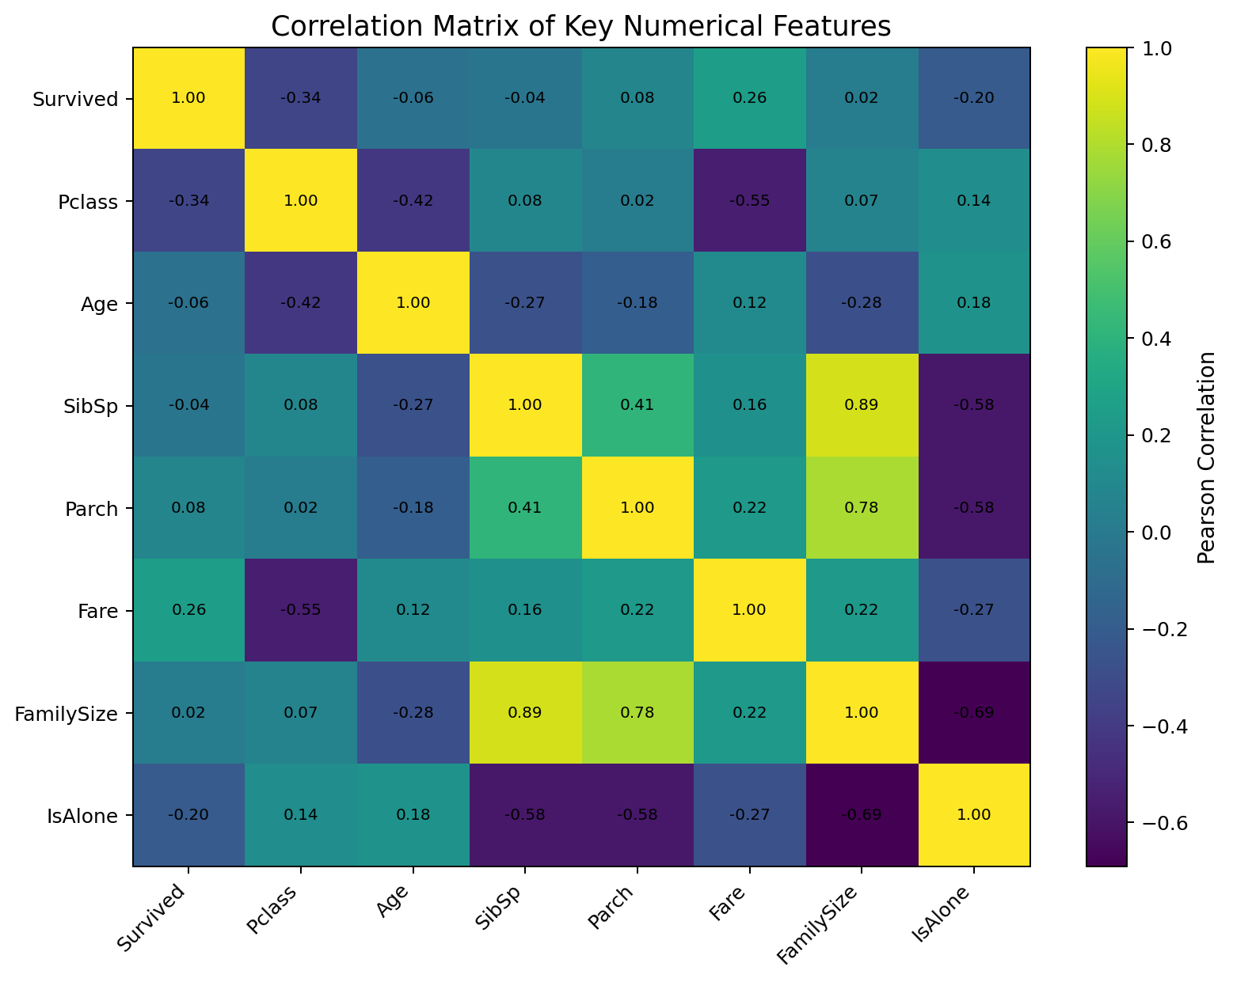
Figure 10. Pearson correlation matrix for selected numerical features.
The correlation matrix summarizes linear associations among the main numerical variables. The most notable relationships include the negative association between Pclass and Fare because lower numerical class values represent higher passenger class and are associated with higher fares, and the relationship between FamilySize and IsAlone because the latter is derived from family structure.
The correlation between Survived and Sex is not included here because Sex is categorical. More generally, correlation should not be used to infer causation, and Pearson correlation captures linear relationships only.
corr_cols = ["Survived","Pclass","Age","SibSp","Parch","Fare","FamilySize","IsAlone"]
correlation_matrix = df[corr_cols].corr()
print(correlation_matrix)

15. Transformations and Aggregations
EDA becomes more informative when raw fields are transformed into interpretable analytical features. The following transformations were used:
Feature | Transformation | EDA Purpose
FamilySize | SibSp + Parch + 1 | Represents the size of the passenger's family group.
IsAlone | 1 when FamilySize = 1, otherwise 0 | Creates a simple binary travel-context indicator.
AgeGroup | Binned Age | Makes life-stage comparisons easier to communicate.
TicketGroupSize | Count of records sharing Ticket | Useful for understanding shared-ticket structure.
FarePerPerson | Fare / TicketGroupSize | Provides a more comparable fare measure when tickets cover multiple people.
Grouped aggregations such as mean survival rate by sex, class, port, and age group convert row-level data into summaries that are easier to compare. For visualization, percentages are preferred to raw counts when the objective is to compare groups with different sizes.

16. Key Findings
- Overall survival was 38.4%, meaning non-survival was the majority outcome.
- Sex showed the strongest descriptive difference: female survival was 74.2% versus 18.9% for males.
- Passenger class showed a clear gradient: first class 63.0%, second class 47.3%, third class 24.2%.
- Age distributions overlap, so age alone does not provide a clean separation of outcomes.
- Fare is strongly right-skewed, making the median a more robust descriptive statistic than the mean for a typical passenger.
- Traveling with family was associated with a higher survival rate (50.6%) than traveling alone (30.4%).
- Port-level differences exist, but passenger composition differs substantially by port, so causal interpretation would be inappropriate.
- Multivariate subgroup analysis shows that sex and class should be considered together in any later predictive model.

17. Critical Interpretation and Limitations
- EDA identifies associations and patterns; it does not establish causality.
- Some groups are much smaller than others, so extreme percentages can be unstable.
- The Titanic dataset is historical and observational, so selection effects and missing context are unavoidable.
- Several variables are related by construction. For example, IsAlone is derived from FamilySize, and FamilySize is derived from SibSp and Parch.
- Repeated ticket numbers can represent multiple people, so rows are not always independent in the real-world sense.
- The Week 1 preprocessing choices influence the EDA. For example, imputed ages allow complete age distributions but introduce estimated rather than directly observed values.
- The Fare variable contains genuine high values. Treating all extremes as errors would remove potentially meaningful information.

18. Reproducibility
The accompanying Python script, eda_titanic.py, reproduces the main summaries and visualization logic. The project folder also includes the cleaned CSV used by the report and a figures directory containing the report-ready charts.
# Reproduce the project
import pandas as pd
df = pd.read_csv("titanic_cleaned.csv")
print(df.shape)
print(df.groupby("Sex")["Survived"].mean())
print(df.groupby("Pclass")["Survived"].mean())

19. Conclusion
The EDA demonstrates how descriptive statistics, aggregation, and visualization can convert a cleaned passenger dataset into interpretable evidence. The most prominent patterns concern sex, passenger class, and the interaction between them, while age, family structure, port, and fare provide additional context.
The analysis also demonstrates an important practical EDA principle: visual patterns must be interpreted alongside sample sizes, variable definitions, and possible confounding relationships. The resulting findings provide a strong foundation for later internship tasks involving unsupervised learning, supervised prediction, and the final capstone.

Appendix A — Complete EDA Script
The complete runnable script is supplied as a separate file in the project package. The main analytical operations are reproduced below for documentation.
"""
Week 2 - Exploratory Data Analysis and Visualization
Dataset: Titanic passenger dataset cleaned during Week 1.
Purpose:
- Load the Week 1 cleaned dataset
- Perform descriptive EDA
- Explore survival patterns across demographic, class, fare and family variables
- Create annotated visualizations
- Compute correlations
- Produce reproducible summary tables
Run:
python eda_titanic.py
"""
import pandas as pd
import numpy as np
import matplotlib.pyplot as plt
DATA_PATH = "titanic_cleaned.csv"
df = pd.read_csv(DATA_PATH)
# 1. Initial inspection
print("Shape:", df.shape)
print("\nColumns:")
print(df.columns.tolist())
print("\nData types:")
print(df.dtypes)
print("\nDescriptive statistics:")
print(df[["Survived","Pclass","Age","SibSp","Parch","Fare","FamilySize","IsAlone"]].describe())
# 2. Overall outcome
print("\nOverall survival rate:", df["Survived"].mean())
# 3. Grouped summaries
print("\nSurvival by sex:")
print(df.groupby("Sex")["Survived"].agg(["count","mean"]))
print("\nSurvival by class:")
print(df.groupby("Pclass")["Survived"].agg(["count","mean"]))
print("\nSurvival by age group:")
print(df.groupby("AgeGroup")["Survived"].agg(["count","mean"]))
print("\nSurvival by embarkation port:")
print(df.groupby("Embarked")["Survived"].agg(["count","mean"]))
# 4. Feature engineering used specifically for EDA
# Ticket group size: how many rows share each ticket?
df["TicketGroupSize"] = df.groupby("Ticket")["PassengerId"].transform("count")
# Fare per person is useful for identifying the effect of shared tickets.
df["FarePerPerson"] = df["Fare"] / df["TicketGroupSize"]
# 5. Visualizations
fig, ax = plt.subplots()
df["Survived"].value_counts().sort_index().plot(kind="bar", ax=ax)
ax.set_title("Passenger Survival Distribution")
ax.set_xlabel("Survival Status (0 = No, 1 = Yes)")
ax.set_ylabel("Number of Passengers")
plt.tight_layout()
plt.show()
# Survival by sex
sex_rate = df.groupby("Sex")["Survived"].mean()
ax = sex_rate.plot(kind="bar")
ax.set_title("Survival Rate by Sex")
ax.set_xlabel("Sex")
ax.set_ylabel("Survival Rate")
ax.set_ylim(0, 1)
plt.tight_layout()
plt.show()
# Survival by passenger class
class_rate = df.groupby("Pclass")["Survived"].mean()
ax = class_rate.plot(kind="bar")
ax.set_title("Survival Rate by Passenger Class")
ax.set_xlabel("Passenger Class")
ax.set_ylabel("Survival Rate")
ax.set_ylim(0, 1)
plt.tight_layout()
plt.show()
# Age distributions by outcome
fig, ax = plt.subplots()
ax.hist(df.loc[df["Survived"] == 0, "Age"], bins=20, alpha=.65, label="Did not survive")
ax.hist(df.loc[df["Survived"] == 1, "Age"], bins=20, alpha=.65, label="Survived")
ax.set_title("Age Distribution by Survival Outcome")
ax.set_xlabel("Age")
ax.set_ylabel("Number of Passengers")
ax.legend()
plt.tight_layout()
plt.show()
# Fare distribution
fig, ax = plt.subplots()
ax.hist(df["Fare"], bins=35)
ax.set_title("Fare Distribution")
ax.set_xlabel("Fare")
ax.set_ylabel("Number of Passengers")
plt.tight_layout()
plt.show()
# Family size
family_rate = df.groupby("FamilySize")["Survived"].mean()
ax = family_rate.loc[family_rate.index <= 6].plot(kind="line", marker="o")
ax.set_title("Survival Rate by Family Size")
ax.set_xlabel("Family Size")
ax.set_ylabel("Survival Rate")
plt.tight_layout()
plt.show()
# Alone vs group
alone_rate = df.groupby("IsAlone")["Survived"].mean()
ax = alone_rate.plot(kind="bar")
ax.set_title("Survival Rate: Alone vs With Family")
ax.set_xlabel("IsAlone (0 = group, 1 = alone)")
ax.set_ylabel("Survival Rate")
plt.tight_layout()
plt.show()
# Port
port_rate = df.groupby("Embarked")["Survived"].mean()
ax = port_rate.plot(kind="bar")
ax.set_title("Survival Rate by Port of Embarkation")
ax.set_xlabel("Embarked")
ax.set_ylabel("Survival Rate")
plt.tight_layout()
plt.show()
# Correlation
corr_cols = ["Survived","Pclass","Age","SibSp","Parch","Fare","FamilySize","IsAlone"]
print("\nCorrelation matrix:")
print(df[corr_cols].corr())
# Interpretation reminder:
# Correlation identifies association, not causation.

